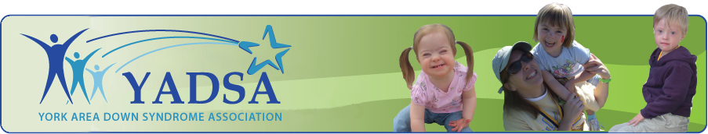

York Area Down Syndrome Association
Grant Application

York Area Down Syndrome Association has started a family grant program. Family grants can be used to provide assistance for anything that directly improves the quality of life of individuals with Down syndrome.

Grants of up to $500 per family will be offered for:
1. Medical expenses not covered by insurance.
2. All therapies for example PT, OT and Speech, not covered by insurance or family driven
money.
3. Family members to attend conferences, seminars or training sessions that address issues
pertinent to Down syndrome.
4. Any other item that will benefit the growth and development of the child with Down Syndrome and their family members.

Application Process
• Grants will be available with a maximum of $500 per family per 12 months. We encourage all
families to apply but we ask you use allotted family driven funds prior to applying for a grant.
• Total amount awarded annually will be based on availability of funds.
• Family grants will be available to all York Area Down Syndrome Association members
equally with no basis on financial status, race or creed.
• Complete the following form and mail to YADSA, P.O. Box 7153, York, PA 17404.
• Direct all questions to yadsagroup@gmail.com.
• Your grant application will be reviewed and funds will be distributed within 30 days. All recipients will be notified by e‐mail or mail.
• A check will be mailed to the family made payable to the provider. YADSA will need a receipt
from provider for tax records.
• Families are requested to contribute 5 hours of volunteer time to YADSA or fundraise a minimum of $500 in one calendar year for YADSA.
Complete applications and mail to:
YADSA
P.O. Box 7153
York, PA 17404

Grant Application
Name___________________________________________________Date__________________
Address_______________________________________________________________________
City_______________________________State________________________Zip_____________
County________________________________________________________________________
Home Phone___________________________________Cell Phone________________________
Email_________________________________________________________________________
Childs Name Receiving Service_____________________________________________________
Date of Birth___________________________________________________________________
Activity for which you are seeking funds_____________________________________________
Dates of Activity________________________________________________________________
Amount/Item Requested $________________________________(max of $500 per 12 months)

Providers Information:
Check made payable to___________________________________________________________
Address_______________________________________________________________________
City, State, Zip__________________________________________________________________
-------------------------------------------------------------------------------------------------------------------------------
Board Member Use Only:
Date Received:______________________________ Date Distributed: ____________________________
Volunteer Time: Date: ____________Hours: __________ Type of Service: ___________________
Volunteer Time: Date: ____________Hours: __________ Type of Service: ___________________
Volunteer Time: Date: ____________Hours: __________ Type of Service: ___________________
Board Signature: ________________________________________ Date: __________________________

